Constructor invocation

* ‘new’ keyword is followed by an expression that evaluates to a function object, and (args)
* eg:
  + new Pet('cat', 4)
  + new RegExp('\\d').

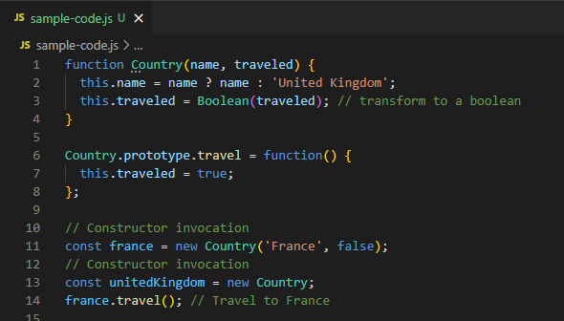

ES2015 – Class syntax

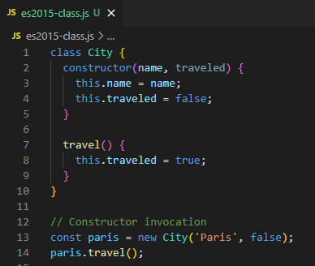

constructor Method

* special method in ES2015 class
* initialize the instance
* creates a new empty object which inherits props from the constructor’s prototype

Example:

new myObject.myFunction()

* this is a CONSTRUCTOR INVOCATION
* not a method invocation
* if a method invocation is preceded with a ‘new’ keyword, it will automatically be a CONSTRUCTOR INVOCATION